Progress Update

1. We selected the right density o.12 which ensures connectivity as noted below:

1. The overall Average Proportion of Preferred Color Nodes: 0.8750553303249897 for the entire dataset
2. A view of the path lengths

1. We selected the ward method because it is more stable, scalable and outperforms the rest of the linkage methods.

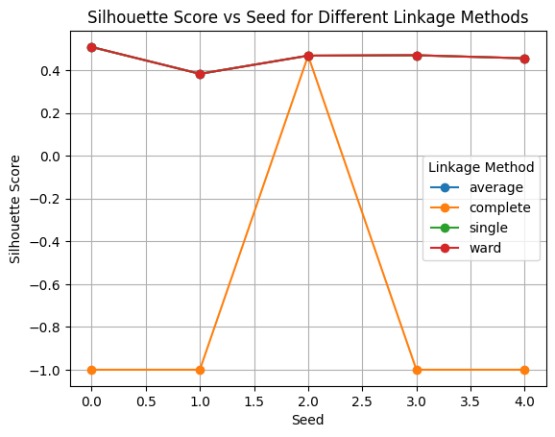

1. The average accuracy vs silhouette score for Ward is:

1. Results of dominant color per cluster
2. Color Counts per Cluster:
3. Color Preference green red
4. Cluster
5. 1 75 0
6. 2 0 88
7. Dominant Color Results:
8. Cluster Dominant Color Dominant Color Percentage
9. 0 1 green 100.0
10. 1 2 red 100.0
11. Out[152]:

|  | **Cluster** | **Dominant Color** | **Dominant Color Percentage** |
| --- | --- | --- | --- |
| **0** | 1 | green | 100.0 |
| **1** | 2 | red | 100.0 |

1. The confusion matrix with 2 clusters show high accuracy rate as follows;

8. I am busy working on refining on scaling the approach and will share the results shortly.